M.S.KIRUBA KARTHIK 192472004
GENERATIVE AI
PRACTICALS
UNIT 1:

1.Install and configure Python, Jupyter Notebook/Google Colab, and required AI libraries (NumPy, Pandas, Transformers, PyTorch).
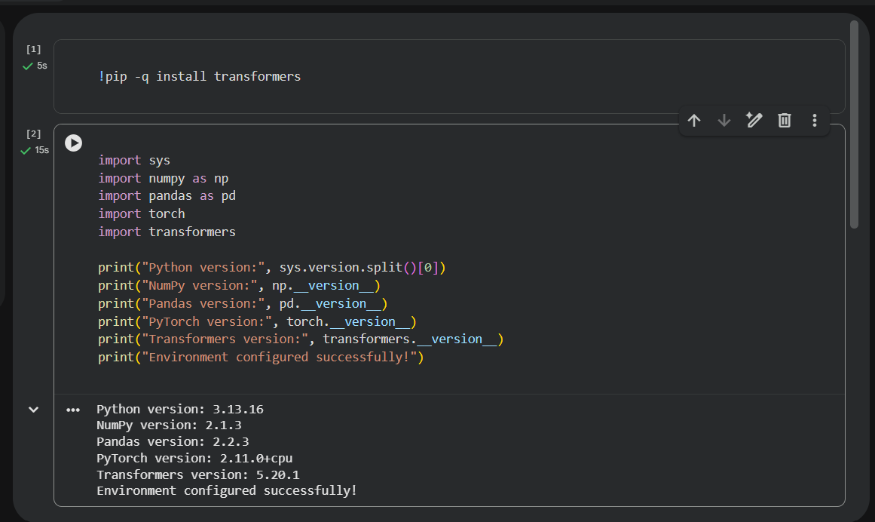

2.the Hugging Face library and load a pre-trained transformer model.
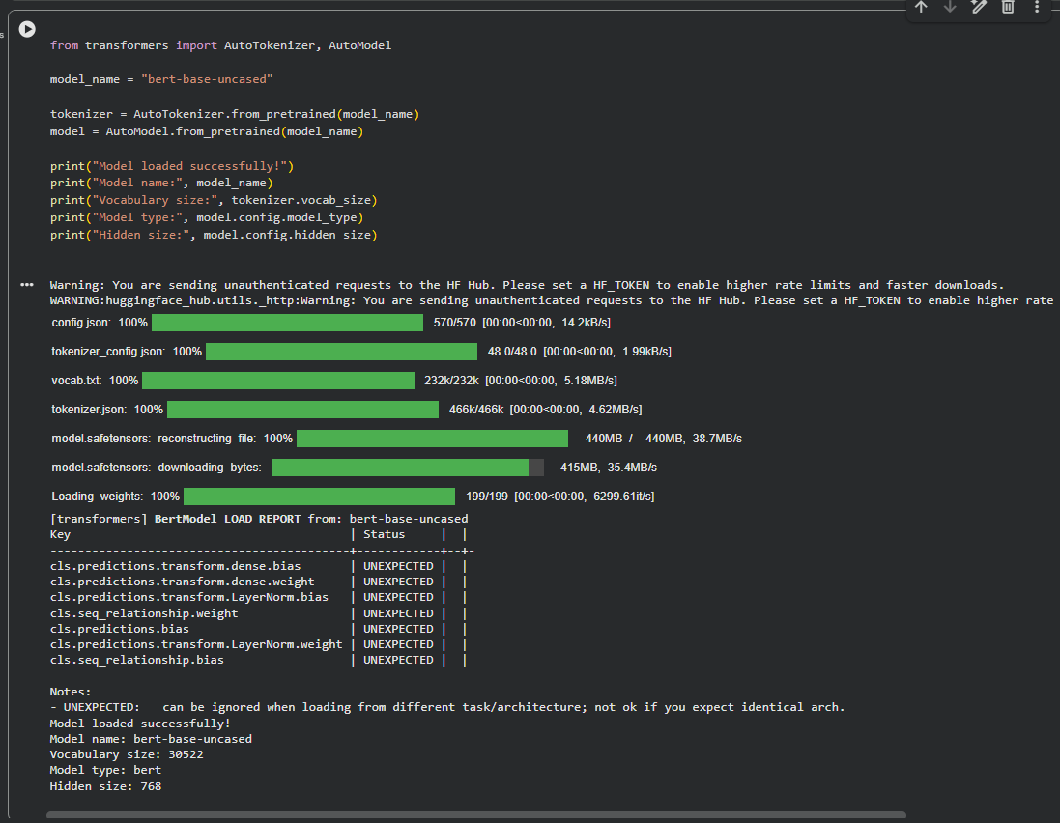

3. Perform tokenization using BERT and GPT tokenizers and compare their outputs
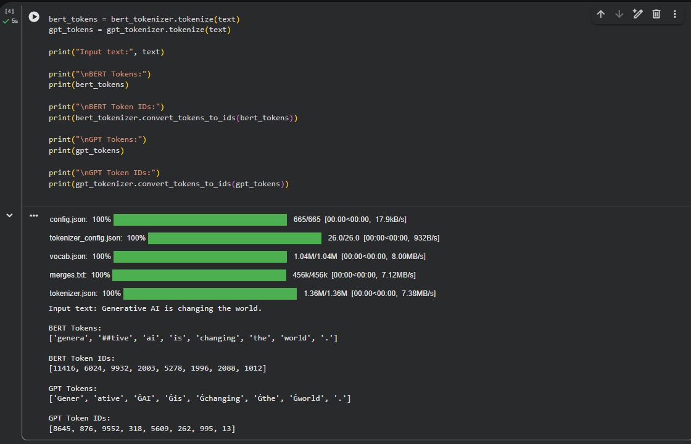
4. Generate contextual embeddings for text using a pre-trained transformer model.
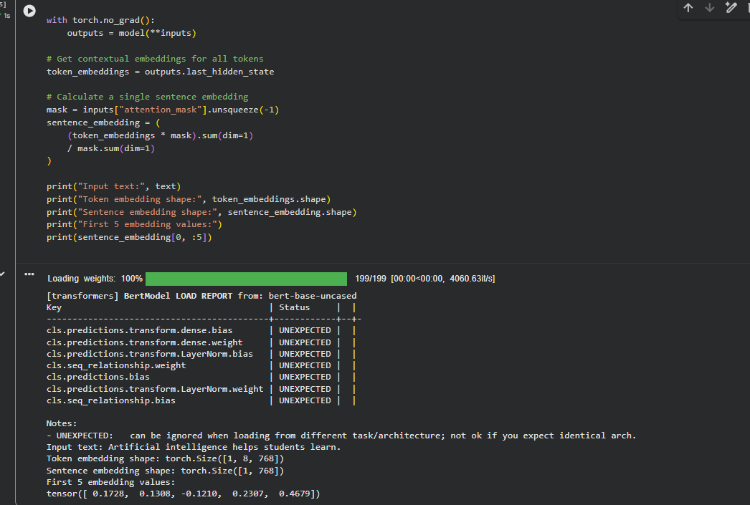
5. Generate text using a pre-trained Large Language Model and analyze the generated responses.

